10+1 Snacks
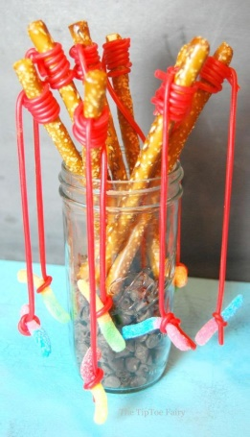
- Fishing rod pretzel sticks: you will need pretzel sticks (preferably larger ones), Twizzlers pull and peel, and gummy worms. Pull apart the pull and peel Twizzler. Wrap one part around the top of the pretzel stick. Then wrap the other part of the Twizzler around the gummy worm. Then you have made your fishing rod.
- Butterfly banana graham crackers: you will need a banana, chocolate chips, pretzel sticks (to use for the antennas instead of straws), peanut butter, graham crackers, and whatever toppings you would like. https://happyhooligans.ca/banana-graham-butterfly-snacks/
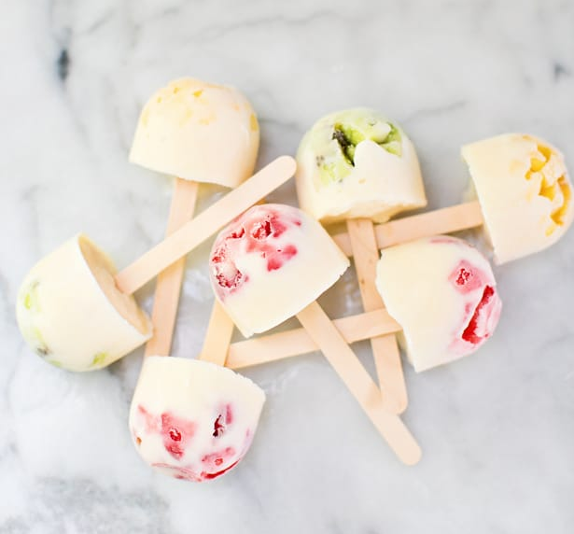
- Yogurt fruit pops: you will need yogurt, chopped fruit, popsicle sticks, and an ice tray/popsicle tray. https://www.hellowonderful.co/post/EASY-FROZEN-YOGURT-FRUIT-POPS/#_a5y_p=3634783
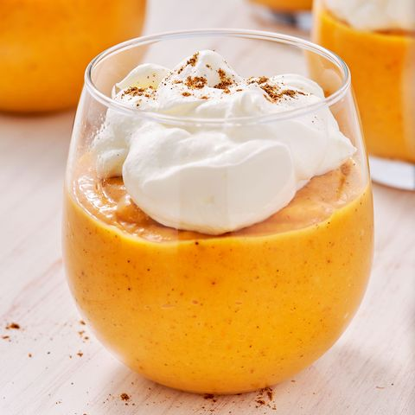
- Pumpkin Pie pudding: you will need canned pumpkin, 1.5 ounce vanilla pudding, 1 tub of cool whip, a container to mix, and a mixing instrument. https://www.highlights.com/parents/recipes/no-bake-pumpkin-pie
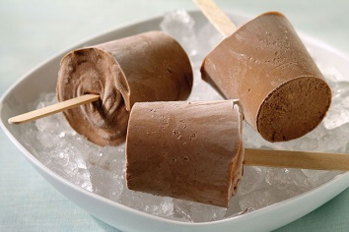
- Pudding Pops: you will need chocolate pudding, cool whip, Dixie cups, and popsicle sticks. (optional: you could put sprinkles on the bottom of the Dixie cups to have decoration on the top of your pops). https://www.myfoodandfamily.com/recipe/050306/creamy-chocolate-jell-o-pudding-pops
- Ladybug apple slices: you will need apples, raisins, peanut butter, and pretzels. https://kidsactivitiesblog.com/75381/apple-ladybug-treats
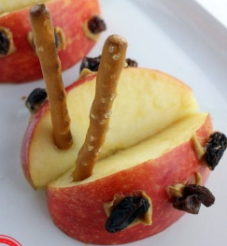
- Ritz pizza crackers: you will need ritz crackers, pizza sauce, sliced pepperoni, shredded cheese, a baking sheet, non-stick spray, and ½ measuring cup. https://www.thereciperebel.com/pizza-crackers/
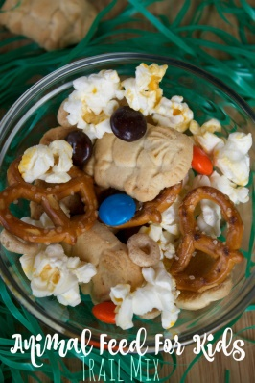
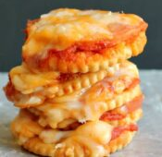
- Animal cracker trail mix: you will need animal crackers, pretzels, mm’s, cheerios, and popcorn. https://momluck.com/animal-feed-for-kids-trail-mix-recipe/
- Fruit Pizza: you will need tortillas, chopped fruit of your choice, and yogurt. https://www.superhealthykids.com/recipes/healthy-fruit-pizza-minis/
- Nutella banana sushi: you will need tortillas, Nutella, and banana. https://www.kidspot.com.au/kitchen/recipes/nutella-banana-sushi-recipe/6m1kfygx
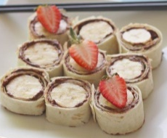
- Peanut butter energy bites: you will need ½ cup chocolate chips, 2/3 cup peanut butter, ½ cup ground flax seeds, 1 cup oats, and 2 tablespoons honey. https://www.seriouslyamazing.xyz/2018/12/no-bake-5-ingredient-peanut-butter.html

