Supporting Organizations

K-Prep Learning Center is licensed annually by the Pennsylvania Department of Human Services. The PA state regulations that all childcare centers must adhere to can be found at http://www.dhs.pa.gov/. A paper copy is also available for review at K-Prep. In addition to a yearly inspection, there may be unscheduled inspections throughout the year. A current inspection certificate is posted in the Family Resource Center, and families may contact DHS for any further reports. The MPI number that distinguishes K-Prep Learning Center is 101626910-0001.

Early Learning Resource Centers (ELRCs) were created to improve the quality of and access to early learning services in PA and help families identify the best child care options that meet the needs of the child(ren), while offering connections to additional services, such as a child care subsidy. To find your local ELRC office, go to www.raiseyourstar.org

Keystone STARS

Standards ~ Training ~ Assistance ~ Resources ~ Support

Keystone STARS is an initiative of the Office of Child Development and Early Learning (OCDEL) to improve, support, and recognize the continuous quality improvement efforts of early learning programs in Pennsylvania. Keystone STARS was originally a voluntary program that K-Prep chose to join in Spring of 2014. For more information about Keystone STARS, visit www.papromiseforchildren.com.

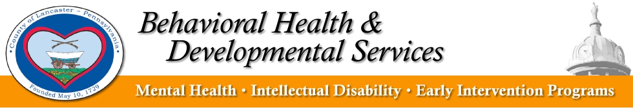
Lancaster County Early Intervention
717-399-7323 HMREarlyInt@co.lancaster.pa.us

Early Intervention is for children ages 0 – 3 years old. They provide FREE services and supports to families with children who have developmental delays. Supports are based on the unique strengths and needs of the child and family to enhance the child’s development. Supports are designed to:
- Answer questions about your child’s development
- Assist you and your child throughout daily routines at home and in the community
- Enhance your child’s development and educational growth
- Support your child to become more independent
- Provide awareness in the community about the gifts and abilities of all children
- Prevent costly intervention in the future

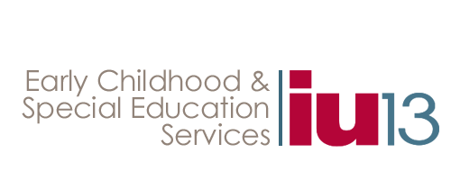
Lancaster Lebanon Intermediate Unit 13
888-745-0771 specialeduation@iu13.org

The Early Intervention Program of IU13 provides FREE support and services to children, from age three to age five, with disabilities and the need for specially designed instruction. Children may be eligible for Preschool Special Education by meeting the criteria for one of several disability categories including, but not limited to, speech or language impairment, developmental delay and emotional disturbance. For children determined eligible for Preschool Early Intervention, an Individualized Education Program (IEP) is developed to determine the appropriate supports and services. Early Intervention services must be delivered in the setting(s) consistent with the educational needs of the child. Services may be provided in settings such as, but not limited to, local childcare centers, community preschools, Head Start Programs, specialized settings, or in the home.

